Project 5.

Web Performance optimization.

Tricks and strategies.
- Minify, Compress, Cache.
  - HTML, CSS, JS.
- Minimize use of render blocking resources (CSS).
  - "media" attribute for the <link rel="stylesheet"> tag.
  - inline CSS.
- Minimize use of parser blocking resources (JS).
  - defer JS execution.
  - javascript - async attribute. css blocks and html and js. with the async - not.
  - javascript - in the script tag to avoid fetching external file (if using only in one place).
  - <script> tag above <link css> - js don't block on css.

Patterns:
- Minimize bytes (Critical bytes)
- Reduce critical resources (Critical resources)
- Shorten CRP length (Critical length (roundtrips))

Add-s:
Preload scanner - discovers critical resources.

Browser Rendering optimization.
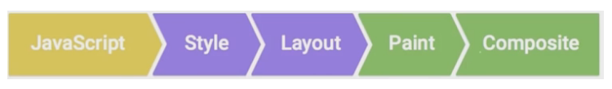

General tips:
- Quit other apps.
- Go incognito.
- Focus on the cause of bottlenecks, not symptoms.
- Measure first, then optimize.

Tricks and strategies.
JS
- Don't use micro-optimizations.
- JS execution – 2-3 ms at most!
- RequestAnimationFrame schedules your JS to run at the earliest moment in each frame. To give browser as much time to run your code, then style, layout, painting and compositing.
- RequestAnimationFrame is called recursively.
- Remember about GC (garbage collector).
- Web Workers – for the long JS executions.
Layout and Styles
- Layout triggers Paint (super expensive, especially on mobile).
- Avoid changing layout during the Animation. Onlly during Load, Idle or Response.
- Performance scales linearly with the number of style changed elements.
- Try to keep selector mathcing simple.
- Avoid Forced Synchronous Layout – doing layout work inside JS and then change styles. Some style properties trigger layout. So read layout properties first then batch your style.
Compositing and Painting
- Use layers.

P5 TODO's
- P5: BRO >>> L4: JavaScript >>> ep. 9 – 10 – Need to install GULP and other.
- P5: WPO >>> L3: Optimizing hte CRP >>> TCP Bonus Question.

